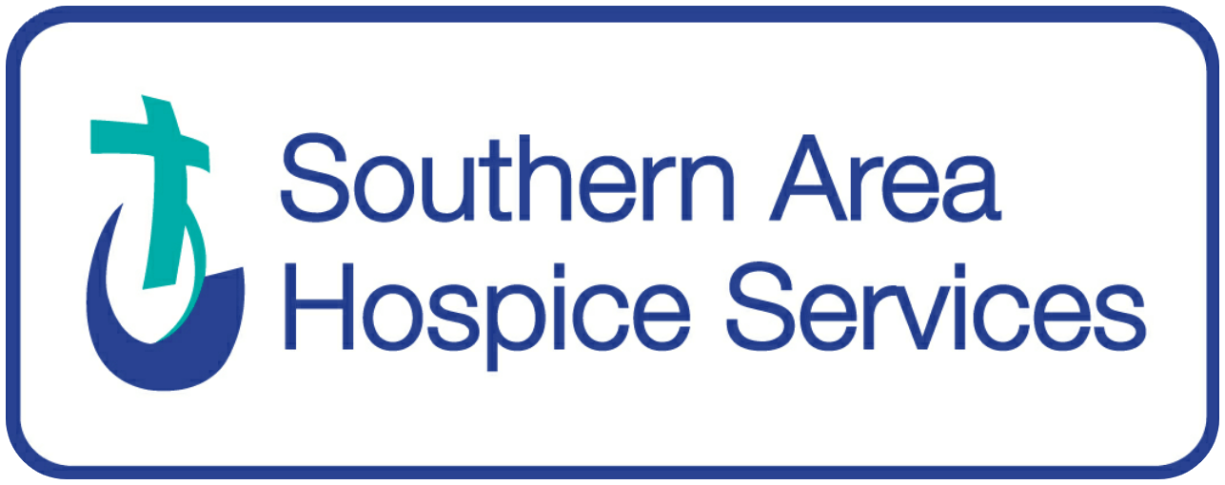

Job Ref: MO/03/23

Medical Officer
(Self Employed)

LOCATION: St John’s House, Courtenay Hill, Newry

PAYMENT: Hospice Sessional Rates

CONTRACT: Self-employed – to provide cover as required for weekends (currently a minimum of 1 in 6 however will decrease if pool of Medical Officers increases), out of hours on call, bank holidays (and related days) and weekdays

Southern Area Hospice Services (SAHS) provides a range of high-quality specialist palliative care services to patients and their families living within the Southern Trust geographical area.
Our services include a 14-bedded specialist palliative care inpatient unit, day therapy hubs and community services team.

We are seeking to recruit Medical Officers for weekday, weekend, and on-call sessions on a self-employed basis.

- Full GMC registration.
- Strong clinical knowledge and experience.
- Excellent communication skills.
- Ideally you will have experience in Palliative Medicine or Oncology, but they are not essential as full training will be provided.

Together with the Multi-Disciplinary Team this role involves planning patient’s daily treatment to ensure that symptoms are controlled, and the quality of the patient's stay is maximised.

We are seeking high calibre individuals with excellent interpersonal and organisational skills who can demonstrate the ability to remain calm under pressure and be sensitive to various situations. Reporting to the Lead Consultant you must be enthusiastic, self-motivated and have the ability to demonstrate initiative and be pro-active.
You will be required to undertake an Enhanced Disclosure through Access NI.
The recruitment exercise is ongoing, and shortlisting and interviews will take place on a regular basis.
If you are interested please visit www.southernareahospiceservices.org for a full application pack or email hr@southernareahospiceservices.org or alternatively contact HR Department, SOUTHERN AREA HOSPICE SERVICES, St. Johns House, Courtenay Hill, Newry, Co. Down, N. Ireland BT34 2EB on 028302 67711.

We are an equal opportunities employer and we welcome applications from all suitably qualified persons. However, people from the Protestant community are currently under-represented in our workforce and, therefore, applications from members of that community are particularly welcomed. All appointments will be made on the basis of merit.

Dignity in Caring
CHARITY NO XN 47329

