


Join us and help make
Every Moment with Everyone

Consultant Physician in Palliative Medicine
Applicant Pack
Reporting to: Lead Consultant
Accountable to: Director of Care Services
Location: Evora Hospice, St John’s House, Newry
Closing: June 2026

Summary of the post

This is a part-time post which will work alongside the existing Palliative Medicine Consultant post.
This post will participate in a 1 in 5, 0.8PA on-call rota 2%.
This post holder will attract a salary of
£106,424 - £139,920 pro rata per annum.
Part-time position (6.8 PAs made up of 6 in hours and 0.8 out-of-hours PA).
Annual leave will be 32 days per annum initially, rising to 34 days after 7 years’ seniority, plus 10 statutory and public holidays pro rata.
The post also has an attractive study leave entitlement of up to 30 days paid leave with expenses in any period of three years.
Evora Hospice is a designated body whose responsible office (RO) is the Medical Director of the Southern Health and Social Care Trust. The Southern Trust has established a dedicated Revalidation Support Team responsible for ensuring that all doctors undergo an annual appraisal conducted by a trained appraiser. The team also provides comprehensive support throughout the revalidation process, in alignment with regulatory requirements.
Evora Hospice supports the requirements for continuing professional development (CPD) as laid down by the General Medical Council (GMC) and is committed to providing time and financial support for these activities.
The post holder will have access to a mentoring service.
The post holder will be appointed at consultant level and will receive the associated terms and conditions of employment, including access to the NHS Pension Scheme.



2

About us

For over 35 years, Evora Hospice (formerly Southern Area Hospice Services) has provided specialist palliative care and support across the Southern Health and Social Care Trust supporting families throughout Counties Down, Armagh, and Tyrone since 1989.
We believe in living well, even in life’s final stages. Our mission is to ensure that every individual with a palliative diagnosis receives the highest quality of care, emotionally, spiritually, and physically, tailored to their unique journey and family needs.
Whether through our welcoming inpatient unit or in the comfort of patients’ homes, we offer a continuum of compassionate support delivered by a closely knit, multidisciplinary team of professionals.

Inpatient Care
- Expert consultants, doctors, and nurses
- Consultant-led medical care delivered by an experienced and dedicated team of doctors and nurses
- Skilled physiotherapists and occupational therapists

Patient & Family Support
- Patient & Family Support offer support in both our inpatient unit and community
- Chaplains and counsellors provide emotional and spiritual care
- Social workers guide families through practical concerns
- Complementary therapists deliver comfort and relaxation

Community Services
  - Services delivered at home or in our wellbeing centres
  - One-to-one support offered by nurses, chaplains, social workers and therapists
  - Counselling support for patients’ carers and bereaved
  - Out-of-hours nursing care and end-of-life support
  - Extensive bereavement services

3

Why families choose Evora

Because we do not just treat conditions, we care for people. With each patient, we build a circle of support that embraces their loved ones. And every service we offer is provided with dignity, comfort, and humanity.
“Every single member of the team, from student to senior management, in every area of Evora (admin, housekeeping, HCA, nurses, doctors & maintenance), has been simply AMAZING!”

Evora Hospice is more than a healthcare provider, we are a sanctuary of compassion and hope, helping patients live and die well, surrounded by care, respect, and love.

Why choose Evora?

A Role with Purpose: You’ll play a pivotal part in helping patients live and die well, making a real difference in people’s lives at their most vulnerable moments.
Collaborative Multidisciplinary Care: Join a well-established team that includes doctors, nurses, physiotherapists, occupational therapists, social workers, chaplains, counsellors and more — all committed to holistic, person-centred care.
Supportive & Innovative Environment: Work alongside experienced professionals in both our inpatient unit and community services, with access to wellbeing centres and out-of-hours care that extend our reach and deepen our impact.
Respected Legacy, Progressive Future: With over three decades of trusted care, Evora is known across the region for its compassionate approach. We're evolving and you can help shape what comes next.

4

90%
Bed occupancy rate


Our year in numbers

239 patients cared for by our Inpatient Unit
664

16.3

57.7%
Patient discharge rate
days

Occupational Therapy 14.6%

Average length of stay in the IPU

Total number of people who received community services
Reflexology 3%

Chaplain 39.6%

Volunteers who help and support us in the hospice
250
Physiotherapy 13.3%

Social Work 29.5%

7,301 sessions delivered by our Inpatient Unit

5

Our mission, vision and values

Our Mission
Our Mission is to provide the highest standard of specialist palliative care to individuals with complex life-limiting conditions, irrespective of their condition or place of care.
We will provide wrap-around support for their physical, emotional and social needs, and will also support their families through this process.

Our Vision
Our Vision is that anyone with a life-limiting condition, and their family, should have access to palliative care of the highest standard to help them to live well with their condition and to ease any avoidable suffering or concerns.

Our Values
We are guided by seven core values that are central to every aspect of our service:
E
x
c
e
l
l
e
i
o


6
n
n
n
D
o
v
i
a
g
t
i
o
n
E
n
n
L
i
c
q
i
t
s
e
t
u
e
y
n
a
i
l
n
i
g
t
y
C
o
I
m
n
t
e
p
g
r
i
t
a
y
s
s
I

Every Moment with Everyone

In June 2025, we officially revealed our new name and brand: Evora Hospice.

At an event in the Seagoe Hotel, Portadown celebrating our 35-year anniversary, we unveiled our new name, brand identity, and website.
Our new name and brand are a true reflection of who we are today: modern, vibrant and rooted in the communities that we serve.

Evora derives from the Celtic word for yew, reflecting our roots in Newry, a word that also means yew. Evora is also the district of Portugal where St John of God was born providing a strong link to our legacy as an organisation founded by the Sisters of the Order of St John of God.
The development of our new name and brand is also about looking confidently to the future and is an important part of our vision to ensure the continued provision of the highest standards of palliative care for many years to come.
Alongside the reveal of our new brand, we also set out our ambition to build a new world-class hospice facility within the Newry area.
Fulfilling this ambition will be a long-term commitment and will require a concerted effort by Evora Hospice, our supporters, stakeholders and the wider community in the years ahead.
But we have great determination to turn our ambition into reality and we look forward to talking to our supporters so we can work together to develop this ambition to meet the growing need for our services in the Southern Health and Social Care Trust region.

Development of our new brand and website was made possible through an award from Dormant Assets NI, delivered by the National Lottery Community Fund.



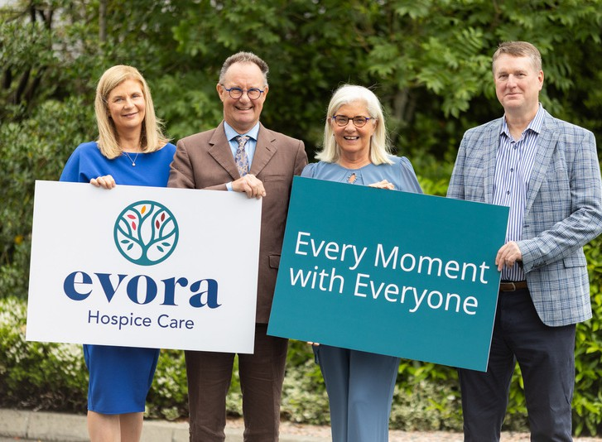

7

The post

This is a 0.6 WTE Palliative Medicine Consultant post working within an established specialist palliative care service providing inpatient and community care. The post holder will work alongside the lead consultant and work in close collaboration with other members of the medical and Multi-Disciplinary Team (MDT).

Duties
The post holder will contribute to the enhancement of palliative care services for patients and their families by promoting high-quality, person-centered care, supporting effective end-of-life care planning, and advancing the development of integrated hospice and community-based palliative care services. In addition, the post holder will support the delivery of specialist palliative care education for both hospice staff and external stakeholders.

- Share responsibility with the Lead Consultant for the specialist palliative care of inpatients at Evora Hospice
- Provide expert consultation and oversight of all aspects of specialist palliative clinical care within the hospice
- Collaborate with all members of the multidisciplinary team to deliver holistic, person-centred care and ensure effective communication with patients, families, carers, and professionals
- Act as a specialist advisory resource for community-based palliative care professionals, including GPs, district nurses, and other specialist team members
- Promote excellence in palliative care by sharing expertise, skills, and philosophy with healthcare professionals to raise standards and awareness
- Lead quality improvement initiatives through clinical audit, risk management, incident reporting, and CPD
- Contribute to the education and training of undergraduate and postgraduate medical staff, as well as other healthcare professionals, in both inpatient and community settings

8

(continued)
Duties

  - Participate in a 1-in-5 second on-call rota (with three other consultants) covering Craigavon Area Hospital, Daisy Hill Hospital, and the hospice, with clinical oversight and rota management responsibilities
  - Contribute to the implementation of the regional Palliative and End-of-Life Care Strategy through active participation in the Trust’s Palliative and End-of-Life Care Steering Group and relevant regional strategic forums, supporting the development and integration of high-quality palliative care services across care settings
  - Share responsibility for the supervision of medical officers in the hospice and membership of senior staff, audit and clinical groups within the hospice
  - Contribute to the development of Evora Hospice services
  - Work closely with the SHSCT palliative medical consultants to ensure collaboration and co-operation
  - Work with the Lead Consultant and Director of Care Services to ensure the high quality, safe and effective palliative care is provided through consultant review, weekly multidisciplinary meetings and quality improvement and governance activities
  - Work with the Lead Consultant and Director of Care Services to maintain safe, effective care through consultant reviews, weekly MDT meetings, and governance activities.

9

Medical staffing inpatient unit

Dr Osmond Morris
Lead consultant 0.7 WTE

Virginia Christodoulou
Specialty doctor 0.7 WTE

Peter Reel
Specialty doctor 0.7 WTE

Team of 10 Medical Officers
GP trained: 1 WTE (Mon-Sun)

Sarah Mooney
Band 8a pharmacist: 1 WTE

Bernie Torley
Consultant nurse: 1 WTE

The hospice inpatient unit is led by the lead consultant, Dr Osmond Morris.
There is one specialty doctor and one medical officer present 9am - 5pm, Monday – Friday. Currently a consultant provides in-person cover Monday, Wednesday and Thursday with Supportive Care UK providing remote consultants cover Tuesdays and Fridays. This new consultant post is designed to provide in-person cover Tuesdays and Fridays and an overlap with Dr Morris on a Monday.
The Out-of-Hours period is covered by a medical officer first on-call and a palliative consultant second on-call.
The second on-call rota is covered by Dr Morris and three NHS palliative medicine consultants working in the Southern Health and Social Care Trust: Dr Sarah Cousins, medical lead SHSCT (Acute), Dr Jayne McCauley (Acute) and Dr Gemma Ryder (Community).
This 2nd on-call rota covers:
  - telephone advice and in-person attendance to Evora Hospice if needed
  - telephone advice only to Community (GP OOHs) and Acute doctors (hospitals covered by Southern Health and Social Care Trust include Craigavon Area Hospital, Daisy Hill Hospital, Lurgan Hospital and South Tyrone Hospital)
Patients are referred to the inpatient unit for complex symptom management, respite and end-of-life care. Referrals to the Inpatient Unit can be from the GP, community and acute specialist palliative care team and consultant clinical staff.
The consultant workforce will be supported by the MDT team that includes: consultant nurse; band 5,6,7 nurses; band 3 HCA; band 8a pharmacist; band 6&7 SW; band 6 chaplains; band 6 OTs; band 6&7 physio and complementary therapists.

10

Key relationships
Governance reporting

  - Lead Consultant at the hospice
  - Director of Care Services
  - Hospice medical team – consultants, specialty doctors, pharmacist and consultant nurse
  - Care services managers (Inpatient services manager, AHP lead, Patient and Family Support Team manager and Community Services manager)
  - Registered nurses and HCAs
  - CEO
  - Director of corporate services
  - Allied health professionals and the wider multi-disciplinary team
  - Other palliative care staff in trusts / locality
  - Clinical governance committee of the board
  - Responsible Officer
  - Weekly Clinical MDT
  - Weekly Incident Meetings
  - Monthly Staff Governance and Senior Management Meeting
  - Monthly Senior Services Meeting
  - Quarterly M&M Meeting
  - Quarterly Medical Officer Meeting
  - Quarterly MAC Meeting
  - Quarterly Clinical Governance Meeting (Board representatives)
  - Evora Hospice Board Meetings – approximately 5 times per annum

11

Accountability

Management & leadership

The post holder is responsible for
delivering high-quality, person-centred

medical care that addresses the physical, psychological, social, and emotional needs of patients, involving them in decisions about their care.
Key responsibilities include:
  - Use advanced clinical judgement and assessment skills to lead the planning, implementation, and evaluation of individualised programmes of care
  - Provide specialist advice and support to relevant specialist teams, including pain services, oncology, and long-term condition teams
  - Act as a clinical resource for primary and secondary healthcare professionals
  - Promote integrated team working across disciplines and care settings
  - Supervise palliative medicine trainees and specialty doctors within Evora Hospice
  - Participate in the consultant second on-call rota
  - Collaborate with consultant colleagues and senior management to develop services
  - Provide strategic oversight in the interpretation, implementation, and continuous review of hospice policies and guidelines, ensuring alignment with evolving national and local clinical frameworks
As a senior member of the medical team, the post holder will:
  - Provide visible and effective medical leadership to foster a cohesive, motivated multidisciplinary team
  - Contribute to clinical governance through active participation in MAC, Governance Groups, and internal strategic meetings
  - Represent the hospice at agreed external forums, including regional and national palliative care networks
  - Collaborate with colleagues to advance palliative care for patients with non-malignant conditions
  - Support service development through engagement in local strategy groups and quality improvement initiatives

12

Education & training

As part of the senior medical team, the post holder will be expected to:
  - Identify and address the educational needs of health and social care professionals in relation to specialist palliative care, ensuring these are met through targeted and responsive training initiatives
  - Contribute to the regional palliative medicine training programme, including the provision of clinical and educational supervision for trainees
  - Embed clinical teaching into daily practice within MDT, fostering a culture of continuous learning
  - Deliver formal and informal education through presentations, group teaching, and one-to-one sessions with medical students, junior doctors, registrars from other specialties, and staff across acute, and community care settings
  - Collaborate with consultant colleagues to ensure robust systems are in place for the ongoing review and development of junior medical staff, supporting their progression and professional growth

Appraisal & revalidation

Evora Hospice supports the requirements for continuing professional development, as laid down by the Royal College of Physicians and is committed to providing time and financial support for these activities.
Evora Hospice is committed to ensuring all doctors have an annual appraisal, with a trained appraiser and fully supporting doctors through the revalidation process.
The post holder will be expected to maintain the requirements for continuing professional development (as indicated by the Royal College of Physicians) by engaging in the annual appraisal and quinquennial medical revalidation process.
The hospice, as a designated body, is part of the Southern Health and Social Care Trust appraisal system.

13

Governance, audit & research

As part of the senior medical team, the post holder will be expected to:
  - Play a key role in Evora Clinical Governance Programme, participating in, and supporting research and audit within Evora at a local level
  - Collaborate with service leads, provide leadership in the development and delivery of clinical multi professional audit to promote evidence-based practice; keep under review medical procedures and prescribing; be involved in risk management and quality assurance.
  - Collaborate with service leads, support a positive approach to research and the continued development of evidence-based palliative medicine; be involved in relevant research in the field of palliative medicine
Undertake all duties in accordance with Evora Hospice policies and procedures and comply with all external
regulatory requirements Promote evidence-based practice by adapting personal and team approaches in response to external guidance, clinical advancements, and organisational priorities
Champion Evora Hospice’s values and the vital role of research in advancing palliative medicine. Where desired, the post holder will be supported by the Director of Care Services to engage in research, with appropriate SPA time allocated for such work

14

Clinical governance

The post holder will be encouraged and supported to report clinical incidents as required, and to work collaboratively with the Director of Care Services and the Clinical Management Team to investigate incidents when necessary.
They will attend the weekly Incident and Safety Meeting and actively contribute to quality improvement initiatives arising from that forum.
The post holder will participate in clinical audits, working alongside our specialty doctor to carry out audits and generate quality improvement plans from audit outcomes.

Managerial & strategic work

The post holder will sit on the Medical Advisory Committee (MAC) alongside the Lead Consultant and Director of Care Services, attending meetings on a quarterly basis.
The post holder will attend the Clinical Governance Subcommittee with the Director of Care and contribute to discussions and decision-making.
In collaboration with the Lead Consultant, the post holder will provide leadership to the hospice medical team and support trainees on placement at Evora Hospice.
In collaboration with the Director of Care Services and the Clinical Management Team, the post holder will contribute to the development of new policies, procedures, and guidelines, and will review existing documents relevant to the medical team in accordance with the hospice’s policy review schedule.

The post holder will work annually with the Lead Consultant and Director of Care Services to develop the medical components of the Hospice Annual Plan.
The post holder will also contribute to the wider clinical strategy and support the development of the medical aspects of that strategy.

15

Medical Governance Structure



Board of Directors

Clinical Governance Committee

Chief Executive Director of Care

MAC

Senior Care Services Meeting
M&M
Medical Officers Meeting
Operational Governance
+ Incident Meetings

16

Other facilities

The post holder will share office space with the existing consultant currently in post.
Secretarial administration and IT support will be provided.

Proposed job plan

This job description is not exhaustive and the timetable acts as a guide which may be amended after 3 months in the post and if needed in the future after discussion with the post holder, Director of Care and Lead Consultant.

On-call summary
Weekday evenings 5pm to 9am the next day, Weekend days and Bank Holidays 9am to 9pm.
AM
Ward Round

Morning Handover & Ward Round

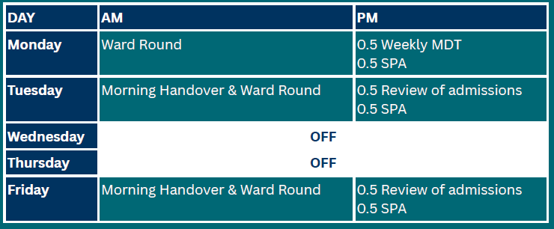
Frequency
1 in 5. Weekly change over on Friday. Category B: 2%
PA allocation: 0.8 PA

Out-of-hour responsibilities
2nd on-call for Evora Hospice – telephone and in-person if required.
Telephone specialist palliative medical advice to acute and community doctors.
PM
0.5 Weekly MDT
0.5 SPA
0.5 Review of admissions
0.5 SPA

Proposed Job Plan when not on-call: 12 weeks in every 16 weeks. Allowances are made in the timetable for lunch.
17
DAY
Monday

Tuesday
Wednesday Thursday Friday
OFF
OFF
Morning Handover & Ward Round
0.5 Review of admissions
0.5 SPA

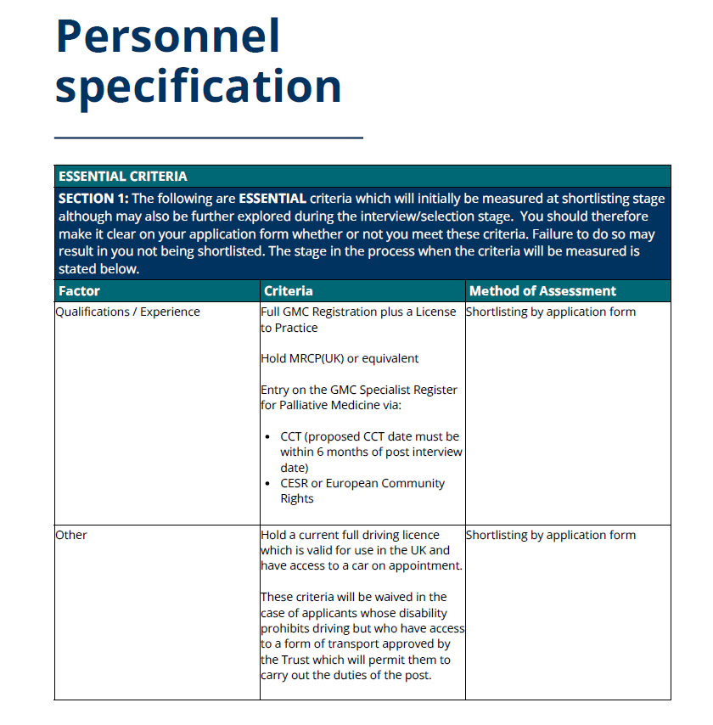

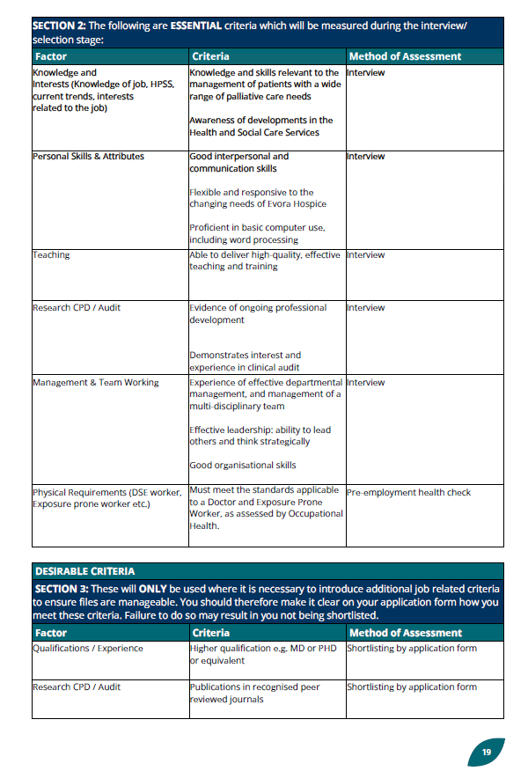
SECTION 2: The following are ESSENTIAL criteria which will be measured during the interview/ selection stage:



Every Moment with Everyone

Evora Hospice
St. John’s House Courtney Hill, Newry Co. Down, BT34 2EB
Northern Ireland Phone: 028 3026 7711

Evora Hospice is a charity registered by the Charity Commission for NI, Registered Charity No. NIC101906; and is a company limited by guarantee incorporated in NI, Company Registration No. NI038737

